# Figures displaying GAGE-B results (A)

Figure S-A 1 Scatterplot of NA50 and N50 statistics on contigs from MiSeq assemblies on *Bacillus cereus* 3

Figure S-A 2 The number of local misassemblies on scaffolds from MiSeq assemblies on *Bacillus cereus* 4

Figure S-A 3 N50 values for contigs and scaffolds from HiSeq assemblies on *Rhodobacter sphaeroides* 5

Figure S-A 4 N50 values for contigs and scaffolds from MiSeq assemblies on *Rhodobacter sphaeroides* 6

Figure S-A 5 Scatterplot on NA50 and N50 statistics on contigs from HiSeq assemblies on *Vibrio cholerae* 7

Figure S-A 6 Scatterplot on NA50 and N50 statistics on contigs from MiSeq assemblies on *Vibrio cholerae* 8

Figure S-A 7 Scatterplot of # misassemblies and # local misassemblies for contigs from HiSeq (1) and MiSeq (2) assemblies on *Vibrio cholerae* 9

Figure S-A 8 Scatterplot of the number of unaligned contigs (Fully and partially) for contigs from HiSeq (1) and MiSeq (2) assemblies on *Vibrio cholerae* 10

Figure S-A 9 Bar chart on N50 statistics on contigs from HiSeq assemblies on *Aeromonas hydrophila* 11

Figure S-A 10 Bar chart on N50 statistics on contigs from HiSeq assemblies on *Bacillus cereus* 12

Figure S-A 11 Scatterplot of the number of contigs and N50 for contigs from MiSeq assemblies on *Bacillus cereus ATCC 10987* 13

Figure S-A 12 Scatterplot of NA50 and N50 statistics on contigs from HiSeq assemblies on *Bacteroides fragilis* 14

Figure S-A 13 Scatterplot of NA50 and N50 statistics on contigs from HiSeq assemblies on *Mycobacterium abscessus* 15

Figure S-A 14 Scatterplot on NA50 and N50 statistics on contigs from MiSeq assemblies on *Mycobacterium abscessus* 16

Figure S-A 15 Scatterplot on NA50 and N50 statistics on contigs from HiSeq assemblies on *Rhodobacter sphaeroides* 17

Figure S-A 16 Scatterplot on NA50 and N50 statistics on contigs from MiSeq assemblies on Rhodobacter sphaeroides 18

Figure S-A 17 Scatterplot on NA50 and N50 statistics on contigs from HiSeq assemblies on *Staphylococcus aureus* 19

Figure S-A 18 Bar chart on N50 statistics on contigs from HiSeq assemblies on *Xanthomonas axonopodis* 20

Figure S-A 19 Scatterplot on #misassemblies and # local misassemblies on contigs from HiSeq assemblies on *Aeromonas hydrophila* 21

Figure S-A 20 Scatterplot on #misassemblies and # local misassemblies on contigs from HiSeq assemblies on *Bacillus cereus* 22

Figure S-A 21 Scatterplot on #misassemblies and # local misassemblies on contigs from MiSeq assemblies on *Bacillus cereus* 23

Figure S-A 22 Scatterplot on #misassemblies and # local misassemblies on contigs from HiSeq assemblies on *Bacteroides fragilis* 24

Figure S-A 23 Scatterplot on #misassemblies and # local misassemblies on contigs from HiSeq assemblies on *Mycobacterium abscessus* 25

Figure S-A 24 Scatterplot on #misassemblies and # local misassemblies on contigs from MiSeq assemblies on *Mycobacterium abscessus* 26

Figure S-A 25 Scatterplot on #misassemblies and # local misassemblies on contigs from HiSeq assemblies on *Rhodobacter sphaeroides* 27

Figure S-A 26 Scatterplot on #misassemblies and # local misassemblies on contigs from MiSeq assemblies on *Rhodobacter sphaeroides* 28

Figure S-A 27 Scatterplot on #misassemblies and # local misassemblies on contigs from HiSeq assemblies on *Staphylococcus aureus* 29

Figure S-A 28 Scatterplot on #misassemblies and # local misassemblies on contigs from HiSeq assemblies on *Vibrio cholerae* 30

Figure S-A 29 Scatterplot on #misassemblies and # local misassemblies on contigs from MiSeq assemblies on *Vibrio cholerae* 31

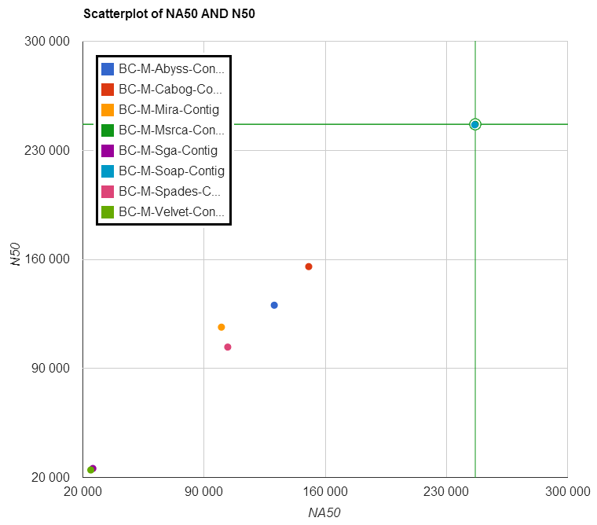

Figure S-A 1 Scatterplot of NA50 and N50 statistics on contigs  
from MiSeq assemblies on *Bacillus cereus*

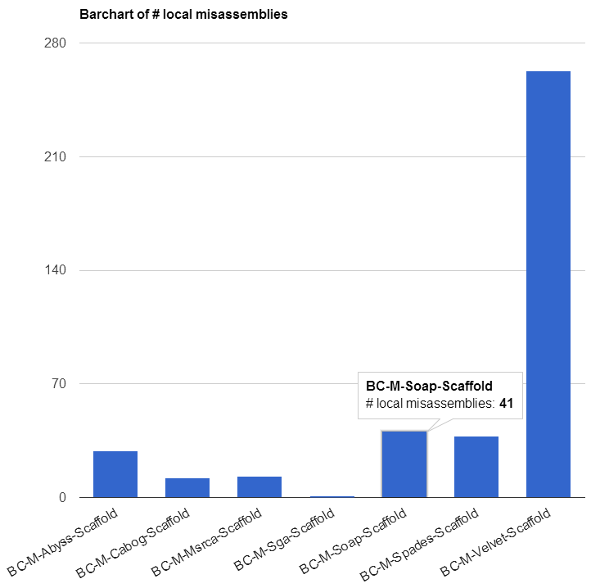

Figure S-A 2 The number of local misassemblies on scaffolds   
from MiSeq assemblies on *Bacillus cereus*

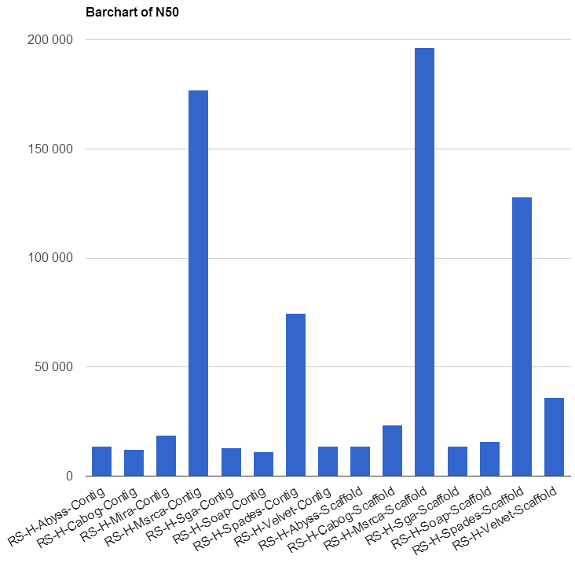

Figure S-A 3 N50 values for contigs and scaffolds from   
HiSeq assemblies on *Rhodobacter sphaeroides*

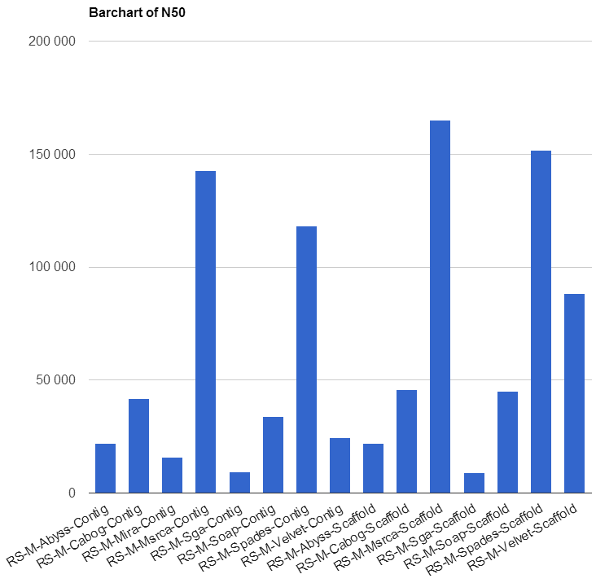

Figure S-A 4 N50 values for contigs and scaffolds from  
MiSeq assemblies on *Rhodobacter sphaeroides*

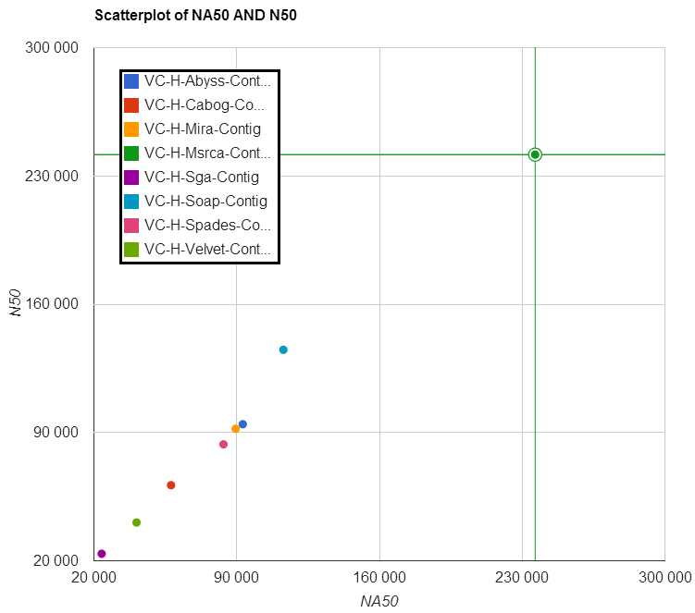

Figure S-A 5 Scatterplot on NA50 and N50 statistics on contigs  
from HiSeq assemblies on *Vibrio cholerae*

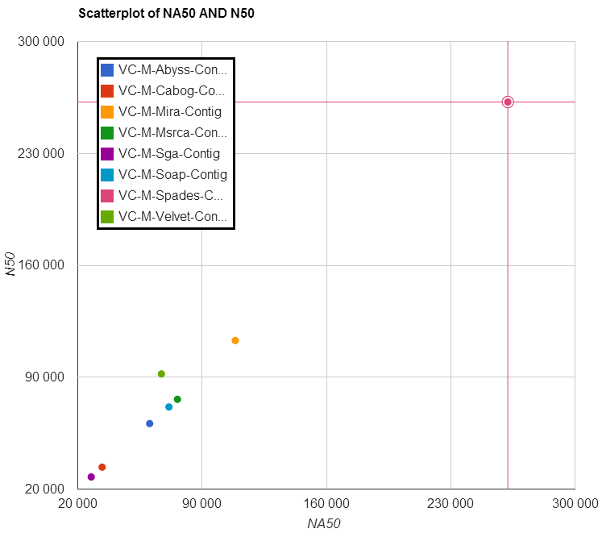

Figure S-A 6 Scatterplot on NA50 and N50 statistics on contigs   
from MiSeq assemblies on *Vibrio cholerae*

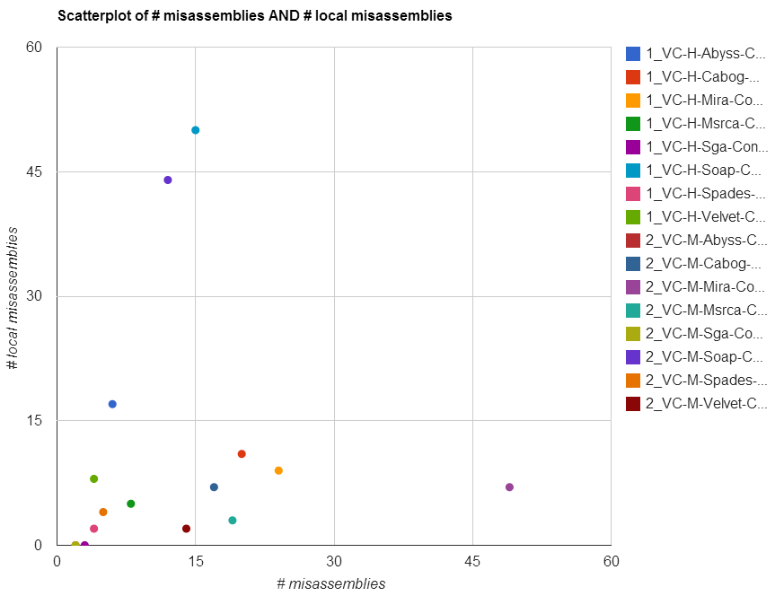

Figure S-A 7 Scatterplot of # misassemblies and # local misassemblies for contigs  
from HiSeq (1) and MiSeq (2) assemblies on *Vibrio cholerae*

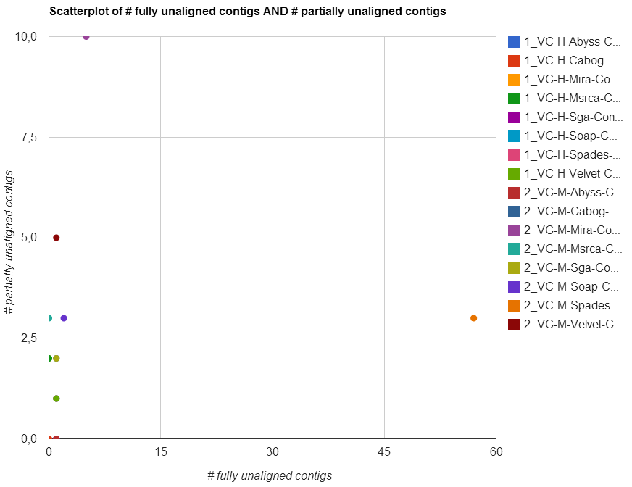

Figure S-A 8 Scatterplot of the number of unaligned contigs (Fully and partially) for contigs from HiSeq (1) and MiSeq (2) assemblies on *Vibrio cholerae*

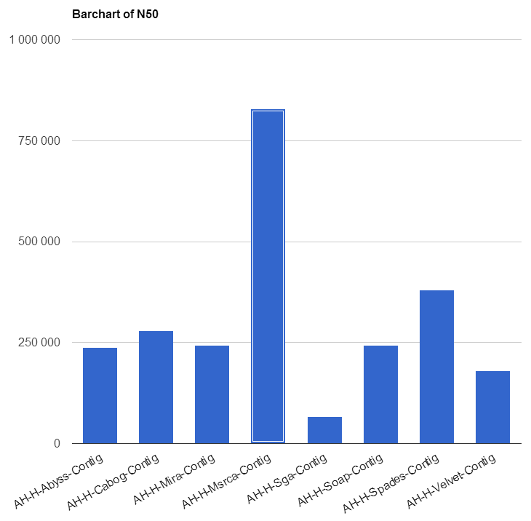

Figure S-A 9 Bar chart on N50 statistics on contigs from  
HiSeq assemblies on *Aeromonas hydrophila*

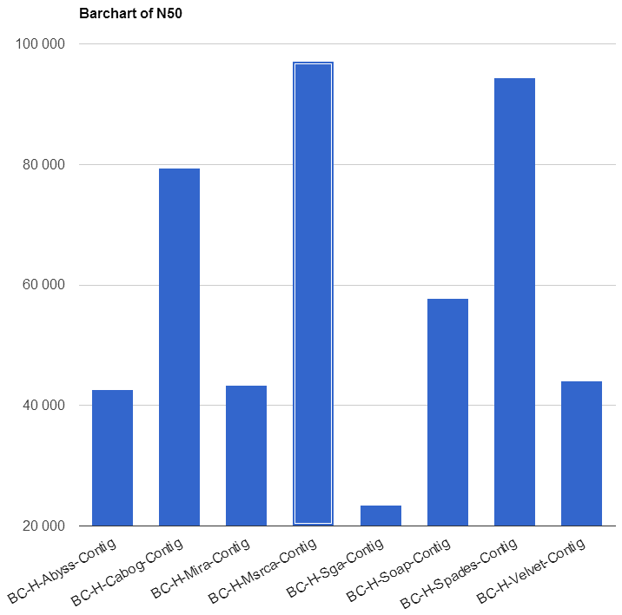

Figure S-A 10 Bar chart on N50 statistics on contigs   
from HiSeq assemblies on *Bacillus cereus*

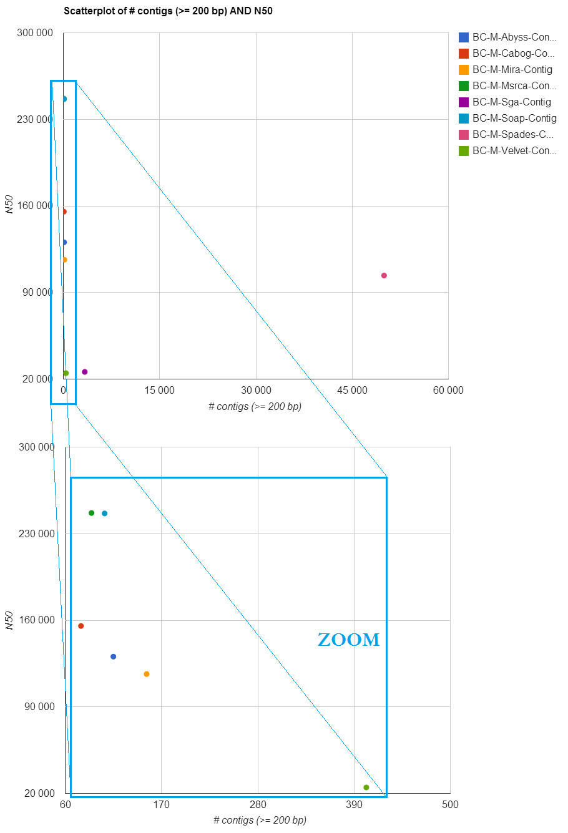

Figure S-A 11 Scatterplot of the number of contigs and N50 for contigs from MiSeq assemblies on *Bacillus cereus ATCC 10987*

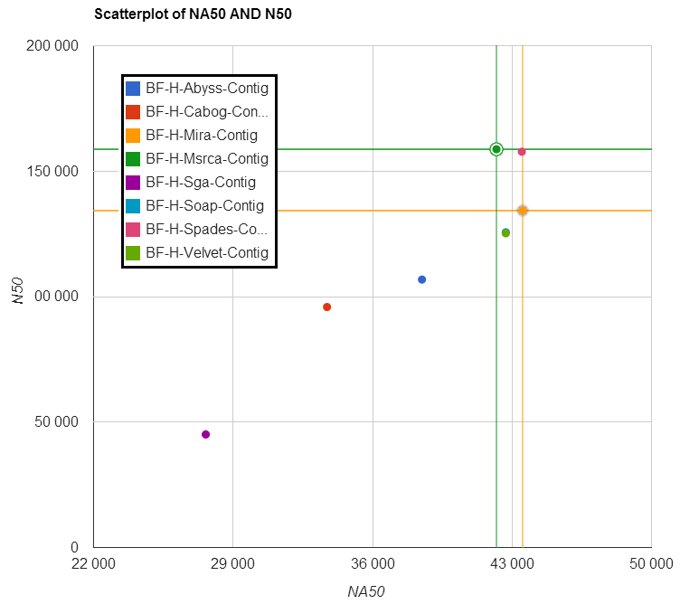

Figure S-A Scatterplot of NA50 and N50 statistics on contigs  
from HiSeq assemblies on *Bacteroides fragilis*

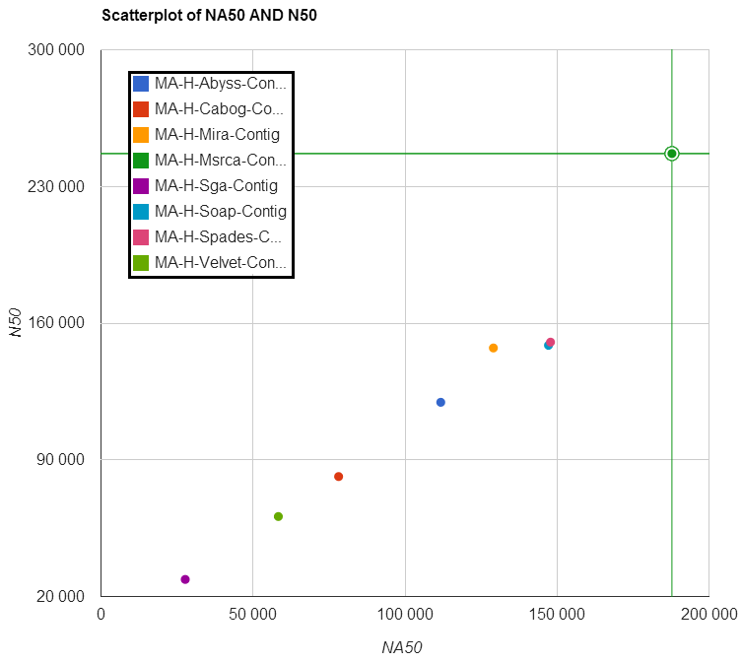

Figure S-A Scatterplot of NA50 and N50 statistics on contigs  
from HiSeq assemblies on *Mycobacterium abscessus*

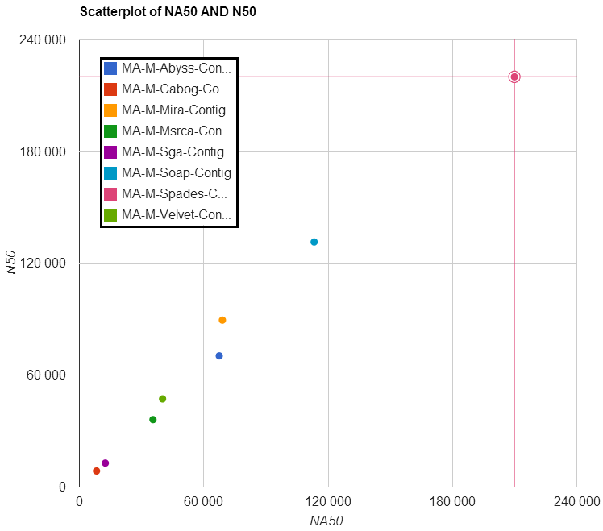

Figure S-A Scatterplot on NA50 and N50 statistics on contigs   
from MiSeq assemblies on *Mycobacterium abscessus*

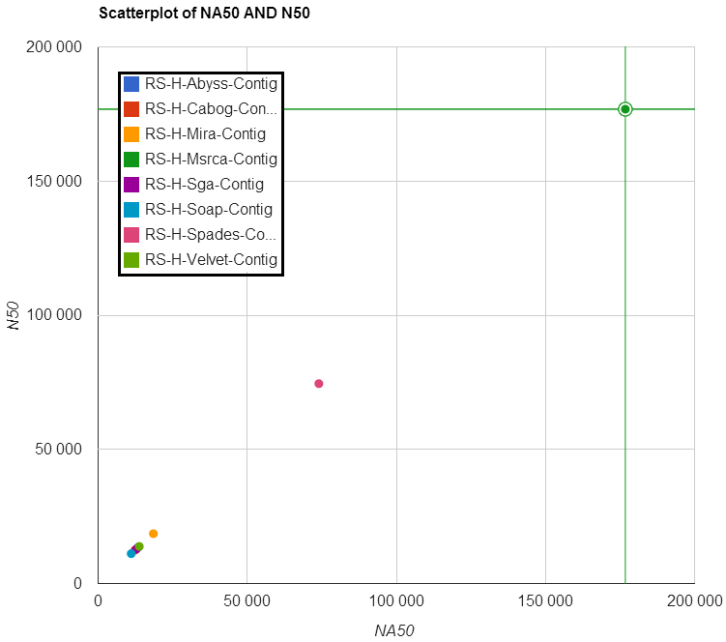

Figure S-A Scatterplot on NA50 and N50 statistics on contigs  
from HiSeq assemblies on *Rhodobacter sphaeroides*

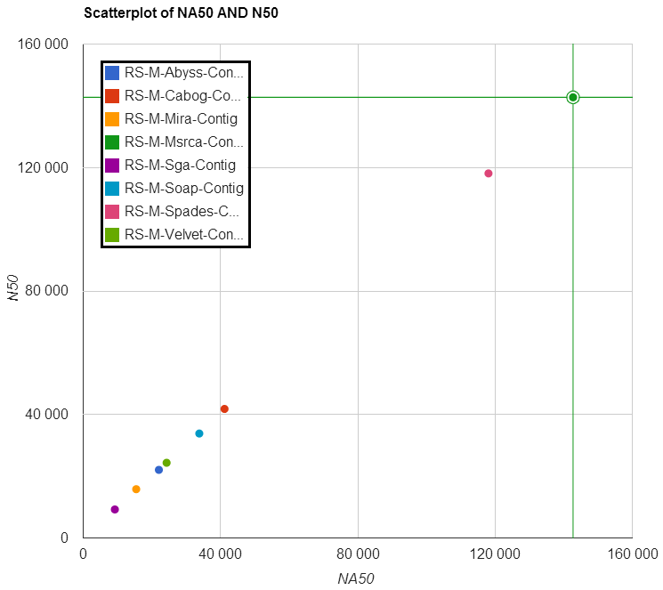

Figure S-A Scatterplot on NA50 and N50 statistics on contigs  
from MiSeq assemblies on Rhodobacter sphaeroides

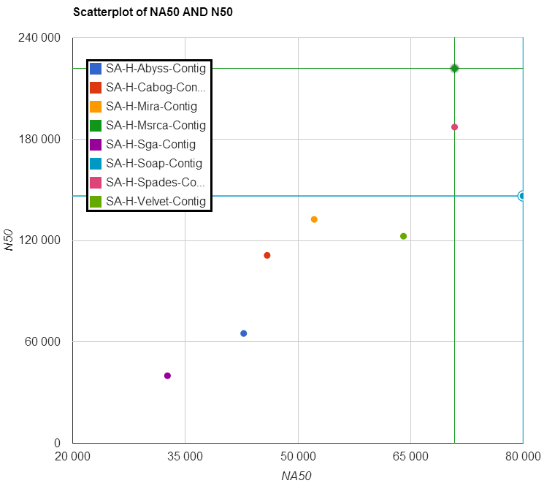

Figure S-A Scatterplot on NA50 and N50 statistics on contigs  
from HiSeq assemblies on *Staphylococcus aureus*

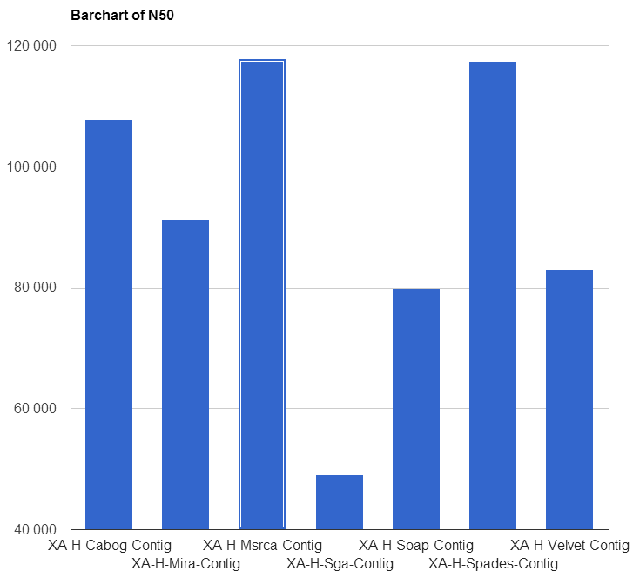

Figure S-A Bar chart on N50 statistics on contigs  
from HiSeq assemblies on *Xanthomonas axonopodis*

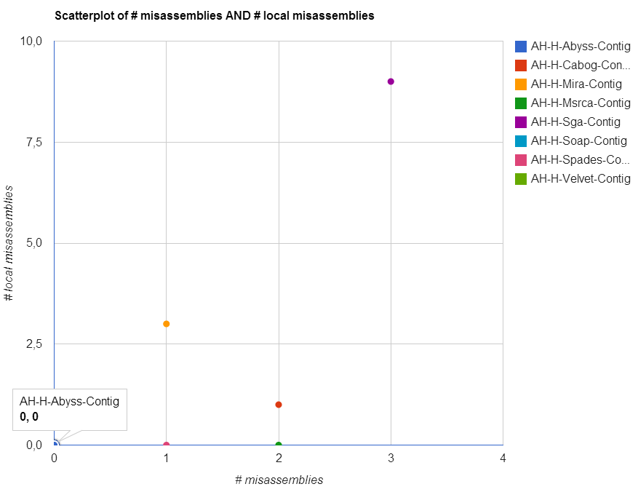

Figure S-A Scatterplot on #misassemblies and # local misassemblies on contigs from HiSeq assemblies on *Aeromonas hydrophila*

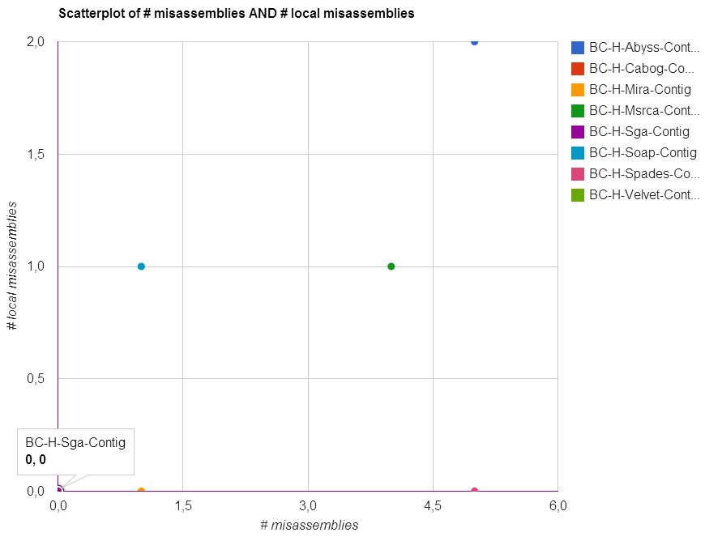

Figure S-A Scatterplot on #misassemblies and # local misassemblies on contigs from HiSeq assemblies on *Bacillus cereus*

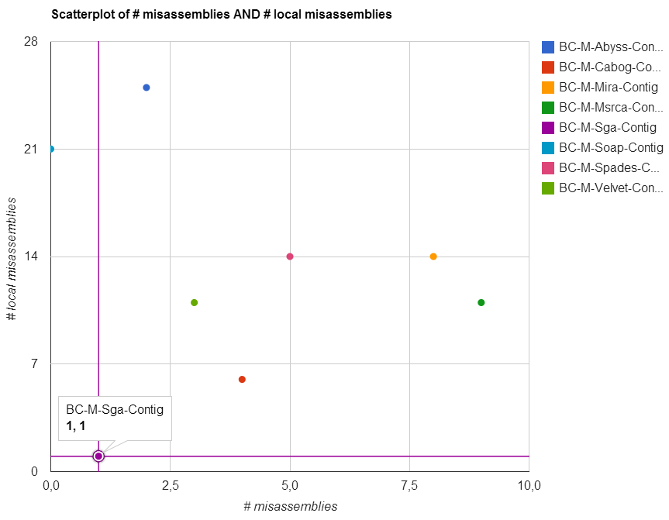

Figure S-A Scatterplot on #misassemblies and # local misassemblies on contigs from MiSeq assemblies on *Bacillus cereus*

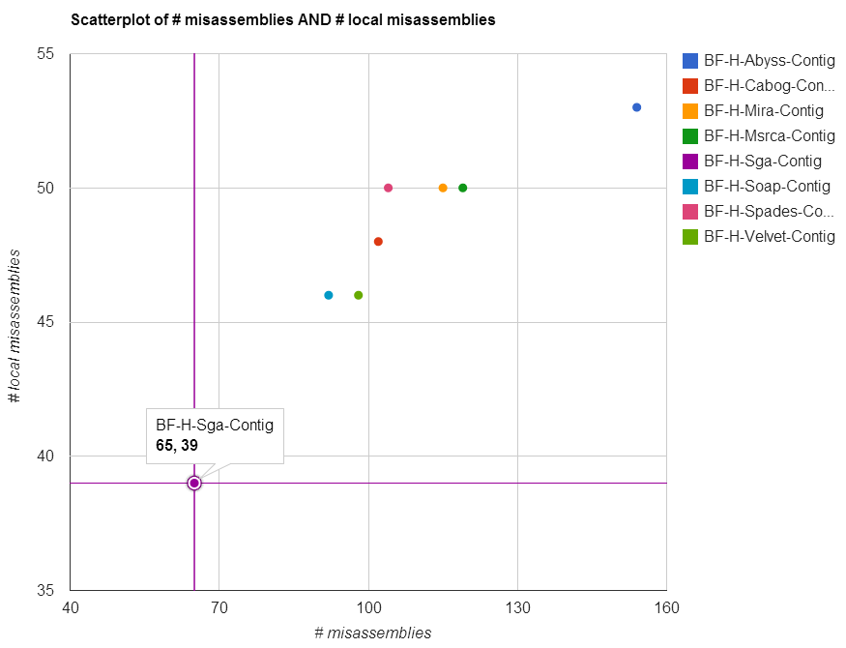

Figure S-A Scatterplot on #misassemblies and # local misassemblies on contigs from HiSeq assemblies on *Bacteroides fragilis*

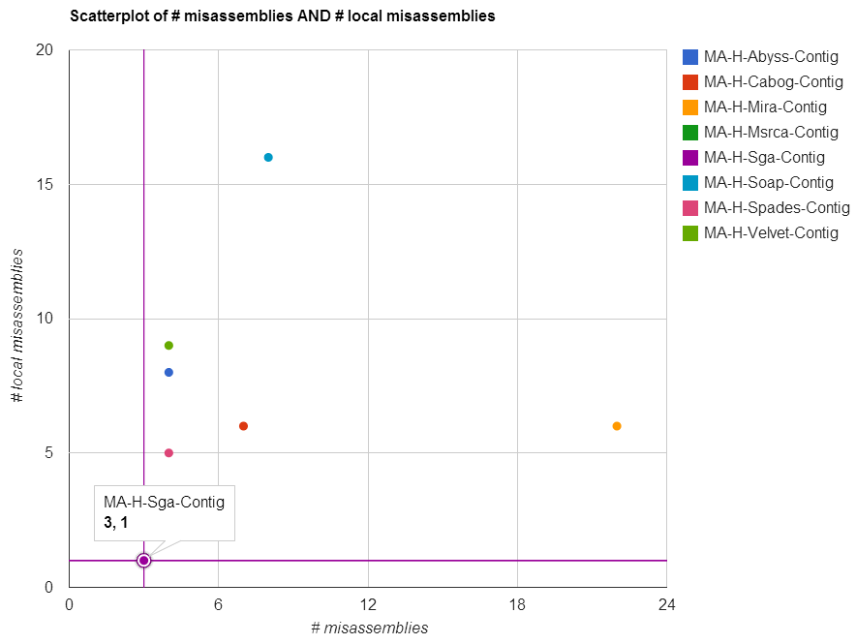

Figure S-A Scatterplot on #misassemblies and # local misassemblies on contigs from HiSeq assemblies on *Mycobacterium abscessus*

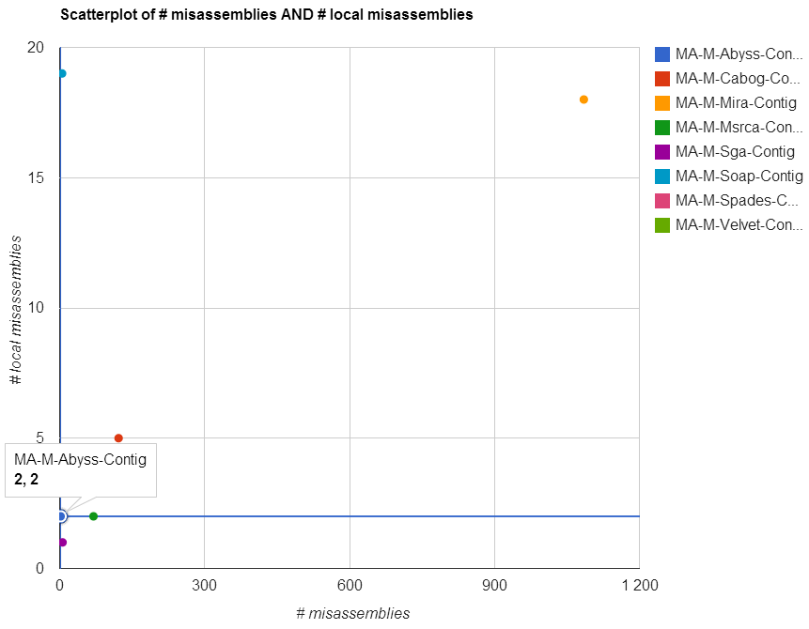

Figure S-A Scatterplot on #misassemblies and # local misassemblies on contigs from MiSeq assemblies on *Mycobacterium abscessus*

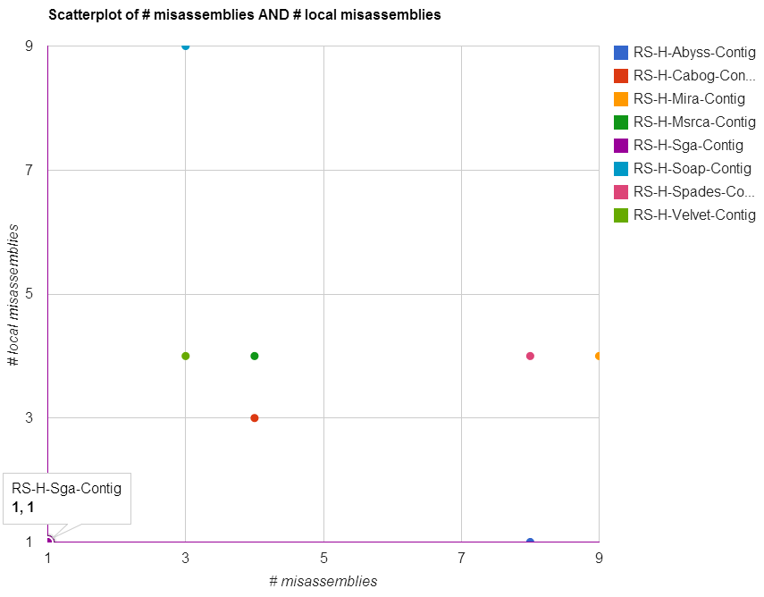

Figure S-A Scatterplot on #misassemblies and # local misassemblies on contigs from HiSeq assemblies on *Rhodobacter sphaeroides*

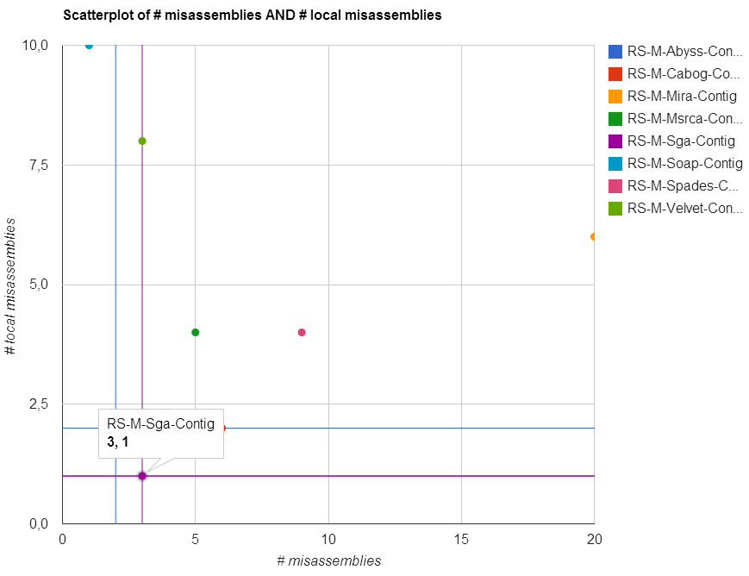

Figure S-A Scatterplot on #misassemblies and # local misassemblies on contigs from MiSeq assemblies on *Rhodobacter sphaeroides*

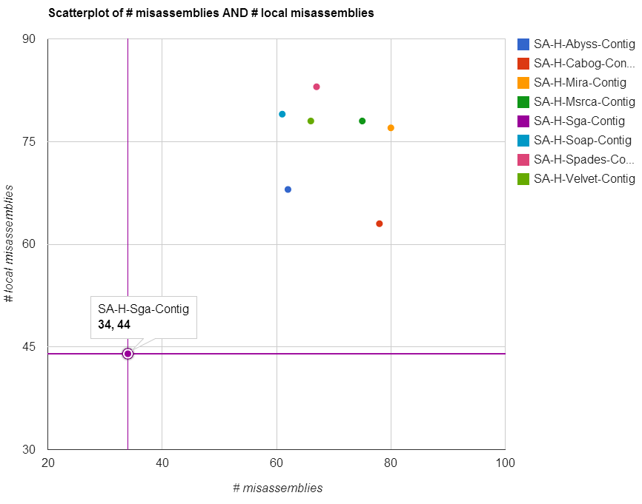

Figure S-A Scatterplot on #misassemblies and # local misassemblies on contigs from HiSeq assemblies on *Staphylococcus aureus*

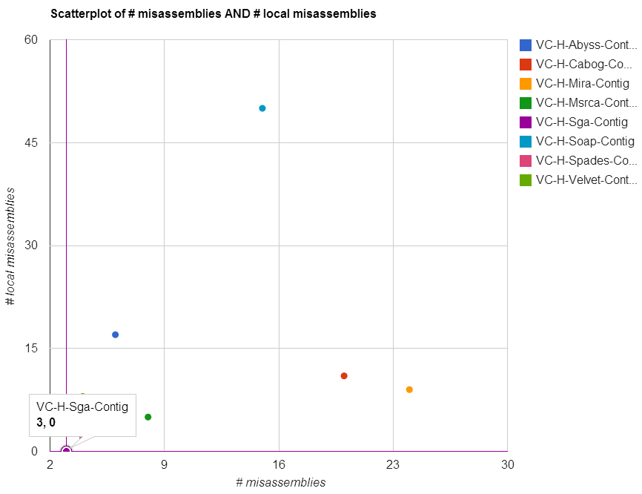

Figure S-A Scatterplot on #misassemblies and # local misassemblies on contigs from HiSeq assemblies on *Vibrio cholerae*

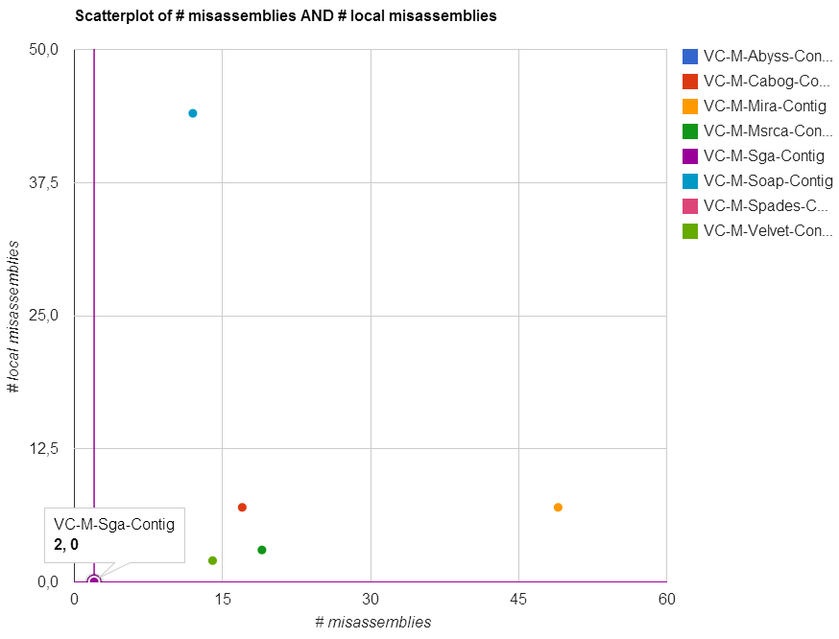

Figure S-A Scatterplot on #misassemblies and # local misassemblies on contigs from MiSeq assemblies on *Vibrio cholerae*